Dis-ME- Assyrian Seal of animals in religious ritual to the moon and the sun-100 BCE

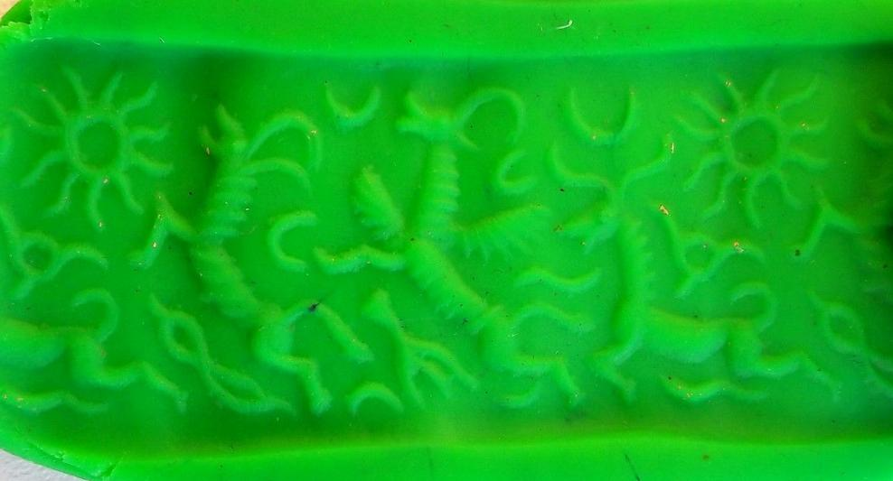

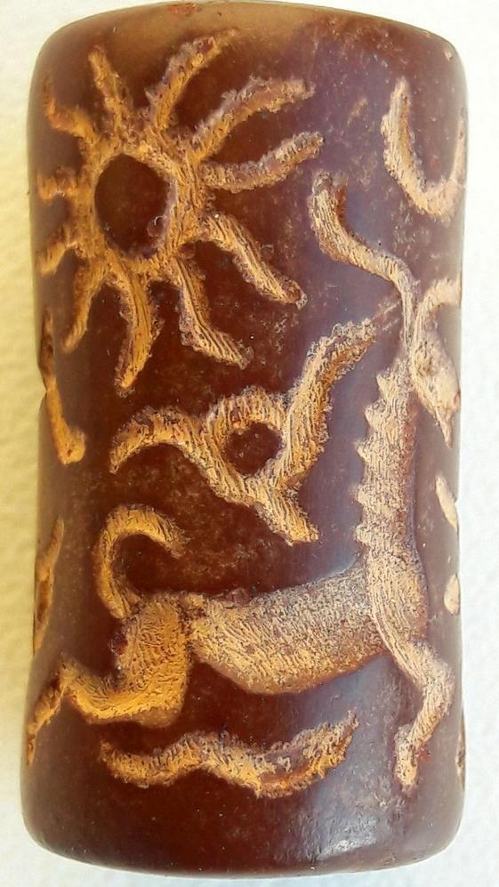 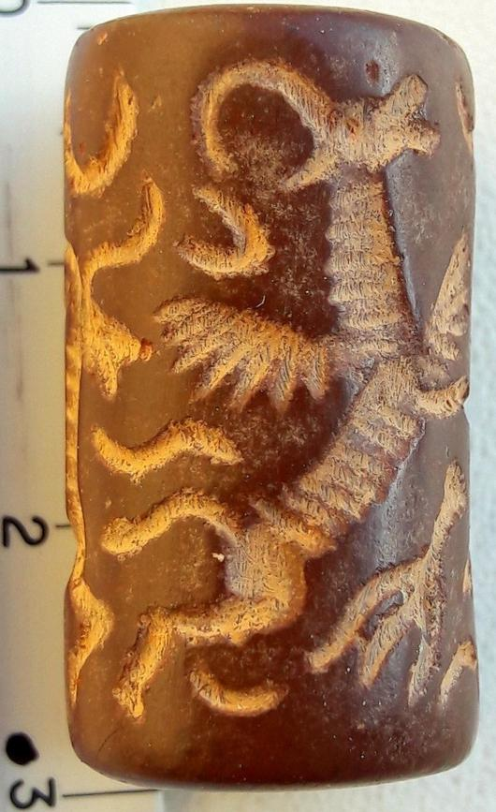 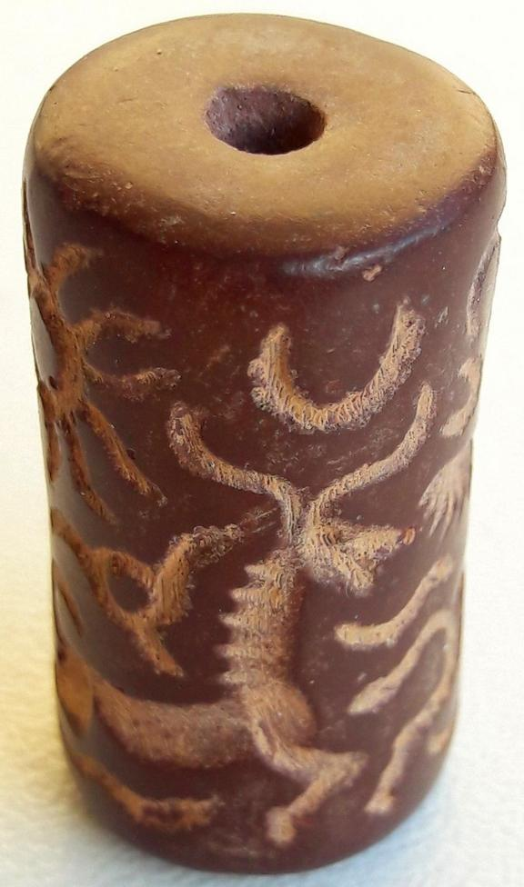

Formal Label: Assyrian Seal of animals in religious ritual to the moon and the sun

Accession Number:

Date or Time Horizon: 100 BCE

Geographical Area: northern Mesopotamia

Cultural Affiliation: Assyrian

Medium:

Dimensions: 27 mm

Weight: 8,7 gm

Provenance:

Sold by [ram-11](http://myworld.ebay.com/ram-11) ( [134](http://feedback.ebay.com/ws/eBayISAPI.dll?ViewFeedback&userid=ram-11) )

Estimated delivery Monday, Dec 19, 2016 - Thursday, Dec 29, 2016

#### [Ancient Assyrian Stone Cylinder Seal.](http://www.ebay.com/itm/122241422515)

|  |  |
| --- | --- |
| Item price | $55.00 |
| Quantity | 1 |
| Item number | 122241422515 |
| Shipping service | Standard Shipping from outside US |